CCDC Windows handbook
PHASE 0
Windows Systems in your diagram
- AD / DNS(Domain controller) → Windows Server 2019
- Web → Windows Server 2019
- FTP → Windows Server 2022
- Workstation → Windows 11

PHASE 1 - Immediate Account Security
1. Rotate ALL Passwords
CHANGE PASSWORDS FOR ALL ADMIN ACCOUNTS
On Domain Controller:
net user administrator *
Check for extra admins
net localgroup administrators
Remove anything suspicious.

2. Disable or Remove Unnecessary Accounts
On Domain Controller
Get-ADUser -Filter * | Select Name,Enabled
Disable anything not required:
Disable-ADAccount -Identity username

3. Enforce Strong Password Policy (Domain)
Group Policy
Computer Configuration →
Windows Settings →
Security Settings →
Account Policies →
Password Policy
Set:
- Minimum length: 14+
- Complexity: Enabled
- Max age: 60 days
- History: 24
- Min age: 1 day
Account lockout
- Threshold: 5
- Duration: 30 minutes
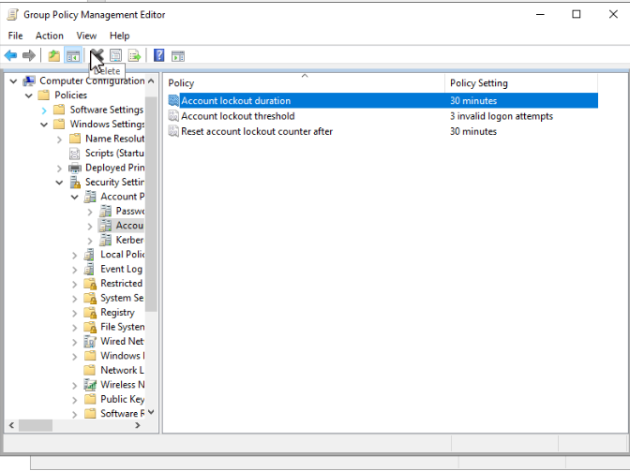
STEP 1 - Open Group Policy Management

STEP 2 - Edit the Default Domain Policy
Password policies must be set at the domain level.
In the left pane:
- Expand your Forest
- Expand Domains
- Click your domain name
- Right-click Default Domain Policy
- Click Edit

STEP 3 — Navigate to Password Policy
In the Group Policy Editor:
Computer Configuration
└─ Policies
└─ Windows Settings
└─ Security Settings
└─ Account Policies
└─ Password Policy

STEP 4 - Configure Password Settings Values
Set the following one by one:
Enforce password history
- Value: 24 passwords remembered
Prevents password reuse.

Maximum password age
- Value: 60 days
Forces periodic changes without annoying users too often.

Minimum password age
- Value: 1 day
Prevents rapid cycling to reuse an old password.

Minimum password length
- Value: 14 characters
This is a huge security boost and CCDC-friendly.

Password must meet complexity requirements
- Enabled
Requires:
- Uppercase
- Lowercase
- Number
- Special character

STEP 5 - Configure Account Lockout Policy
Navigate to:
Account Policies
└─ Account Lockout Policy
Set these values:
Account lockout threshold
- 5 invalid attempts

Account lockout duration
- 30 minutes

Reset account lockout counter after
- 30 minutes
This prevents brute-force attacks.

STEP 6 -Apply & Close
- Close the Group Policy Editor
- Policy saves automatically

STEP 7 - Force the Policy to Apply
On the Domain Controller:
gpupdate /force
On other domain-joined machines (if possible):
gpupdate /force

STEP 8 - Force Users to Change Passwords
To force all users to change passwords at next login:
Run ForcePassChange Script
PHASE 2 - Lock Down Remote Access (EACH WINDOWS MACHINE)
Disable RDP via System Settings
On the machine you want to lock down:
- Press Win + R or search run
- Type:
- SystemPropertiesRemote
- Under Remote Desktop:
  - Select Don’t allow remote connections to this computer
- Click Apply → OK

PHASE 3 — Firewall Hardening (ALL WINDOWS MACHINE)
7. Enable Windows Firewall
Set-NetFirewallProfile -Profile Domain,Public,Private -Enabled True

8. Allow Only Required Ports
Each windows machine has a designated script in the repo. Run the designated script as admin on the machine
Block SMB From Workstation
Workstations should not host SMB
Disable-WindowsOptionalFeature -Online -FeatureName SMB1Protocol

PHASE 4 - Patch
9. Windows Updates
Install-Module PSWindowsUpdate
Get-WindowsUpdate
Install-WindowsUpdate -AcceptAll -AutoReboot
Reboot when needed.

PHASE 5 - Services Hardening(Every MACHINE)
10. Disable Unnecessary Services
On every machine:
services.msc
Disable if unused:
- Print Spooler
- Remote Registry
- Bluetooth
- SNMP
PHASE 6 - Active Directory Hardening (DOMIAN CONTROLLER)
11. Secure Domain Admins
Only 2 users
Domain Admins
Enterprise Admins
Check:
Get-ADGroupMember "Domain Admins"

12. Disable NTLM
Group Policy:
Computer Configuration →
Windows Settings →
Security Settings →
Local Policies →
Security Options
Set:
- Network security: Restrict NTLM → Deny All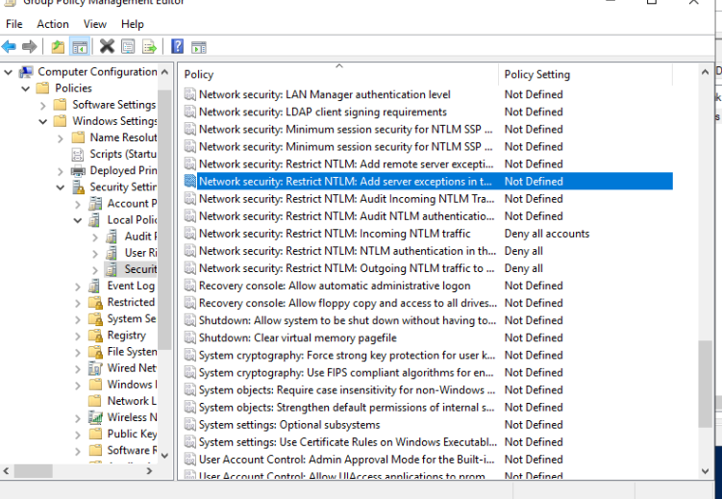

13. Disable Anonymous Enumeration
Network access: Do not allow anonymous enumeration of SAM accounts
Enabled

PHASE 7 - Logging & Detection (Domain controller)
14. Enable Advanced Auditing(DOMAIN)
On the Domain Controller:
- Open Group Policy Management: gpmc.msc
- Edit Default Domain Policy
- Go to:
Computer Configuration
→ Policies
→ Windows Settings
→ Security Settings
→ Advanced Audit Policy Configuration
→ Audit Policies
Enable these categories
Account Logon
- Audit Credential Validation (Success, Failure)
Logon/Logoff
- Audit Logon (Success, Failure)
- Audit Logoff (Success)
- Audit Special Logon (Success)
Account Management
- Audit User Account Management (Success, Failure)
- Audit Security Group Management (Success)
Privilege Use
- Audit Sensitive Privilege Use (Success, Failure)
Policy Change
- Audit Audit Policy Change (Success)
- Audit Authentication Policy Change (Success)
System
- Audit Security System Extension (Success)
- Audit System Integrity (Success, Failure)
Detailed Tracking (big win)
- Audit Process Creation (Success)

Turn on “Process Creation Command Line” logging
This makes Event ID 4688 include the actual command line (how you catch attacker PowerShell).
On each machine (or via GPO):
GPO path
Computer Configuration
→ Policies
→ Administrative Templates
→ System
→ Audit Process Creation
→ Include command line in process creation events = Enabled

Enable PowerShell Logging
GPO path
Computer Configuration
→ Policies
→ Administrative Templates
→ Windows Components
→ Windows PowerShell
Enable:
- Turn on Module Logging
Under Options, next to Module Names, click:
Show…
Add the module names
In the Show Contents window:
Under Value name, type: *

- Turn on PowerShell Script Block Logging
- Turn on PowerShell Transcription
C:\PSLogs\

Apply policy:
gpupdate /force

15. Increase Log Sizes(Every Box)
- PowerShell
- wevtutil sl Security /ms:524288000
- wevtutil sl System /ms:209715200
- wevtutil sl Application /ms:209715200
- 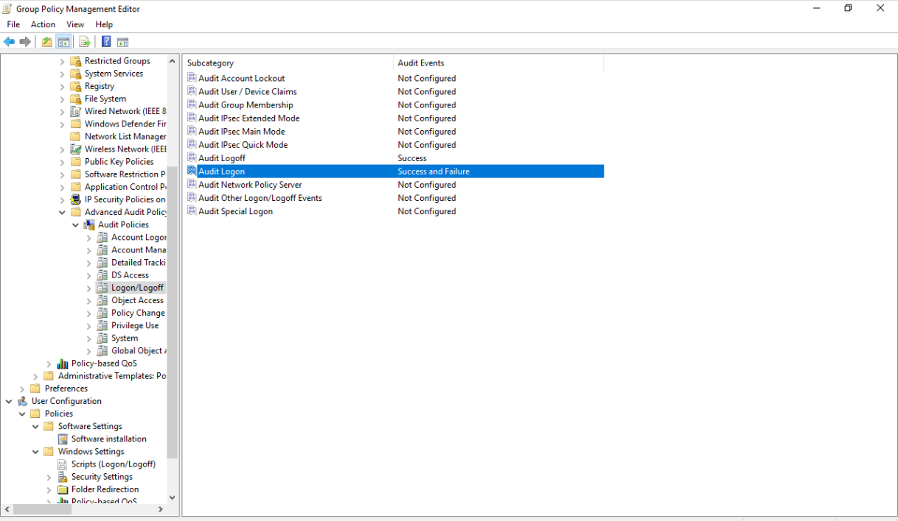

16. Install Sysmon(ALL MACHINES) IMPLEMENTATION WIP
Download Sysmon from browser
Sysmon64.exe -accepteula -i sysmonconfig.xml
This gives:
- Process tracking
- Network connections
- Persistence detection

PHASE 8 — Malware Protection (ALL MACHINES)
17. Microsoft Defender Hardening
Set-MpPreference -DisableRealtimeMonitoring $false
Set-MpPreference -EnableControlledFolderAccess Enabled
Set-MpPreference -PUAProtection Enabled
Run scan:
Start-MpScan -ScanType FullScan

PHASE 9 — Application Hardening
18. IIS Hardening (Web Server)
- Remove unused modules
- Disable directory browsing
- Run site as non-admin
- Remove default IIS pages

19. FTP Hardening
Steps
- Open IIS Manager (inetmgr)
- Expand Sites
- Click Default Web Site
- Open Content View

Disable Directory Browsing
Directory browsing leaks files and configs.
Steps
- In IIS Manager
- Select your website
- Open Directory Browsing
- Click Disable
Verify:
- Browsing to / does NOT show file lists

Remove Unused IIS Modules (Attack Surface)
Steps
- Select the server name in IIS
- Open Modules
- Remove anything not required, such as:
  - WebDAV (VERY dangerous if unused)

Lock Down Application Pool Identity
Steps
- Open Application Pools
- Select your app pool
- Click Advanced Settings
- Set:
  - Identity → ApplicationPoolIdentity
Do NOT run as:
- LocalSystem
- Administrator
- Domain Admin
This prevents full system compromise via web exploit.

Disable HTTP Methods You Don’t Need
Attackers abuse PUT, DELETE, OPTIONS.
Steps
- Select the website
- Open Request Filtering
- Go to HTTP Verbs
- Allow only:
  - GET
  - POST
Remove:
- PUT
- DELETE
- TRACE

Lock File Permissions on Web Root IMPLEMENTATION WIP
Steps
- Right-click the web root folder
- Properties → Security
- Remove:
  - Everyone (write)
  - Users (write)
- Ensure:
  - App pool identity = Read
  - Admins = Full
  - No write permissions unless required
This stops web shells from being written.

PHASE 10 -Persistence & Backdoors Check
22. Startup & Scheduled Tasks
Get-ScheduledTask
Get-ItemProperty HKLM:\Software\Microsoft\Windows\CurrentVersion\Run
Remove anything suspicious.

